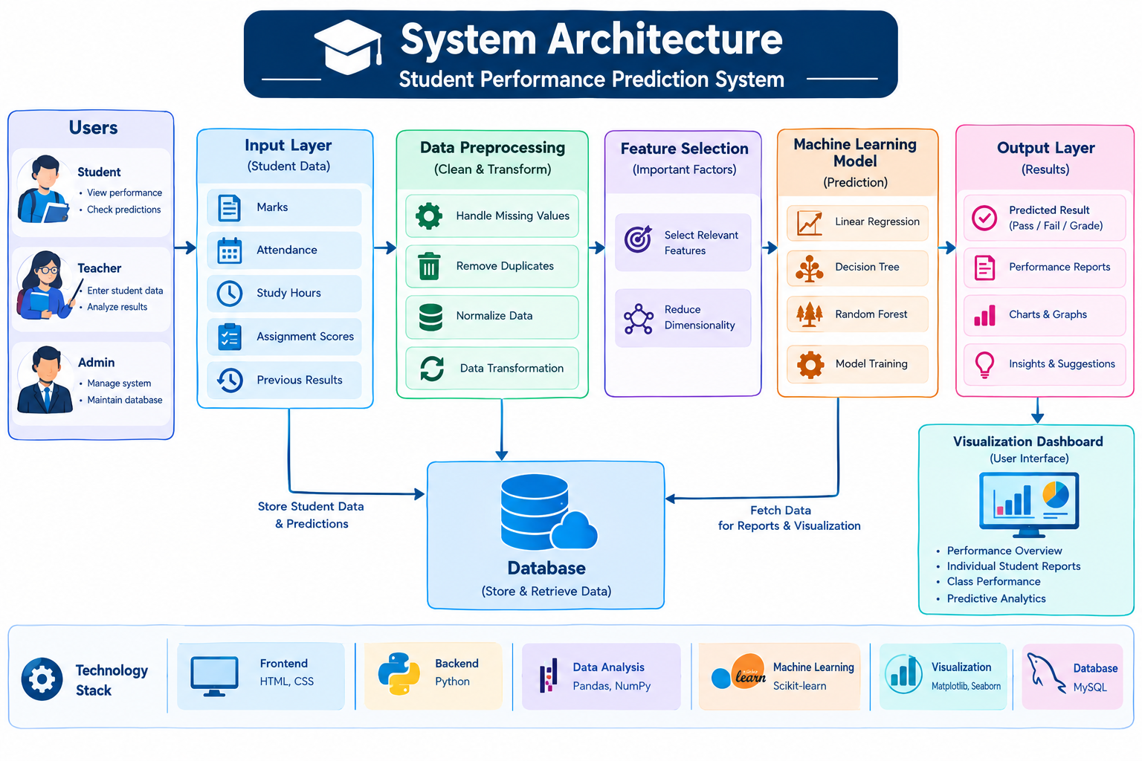

Explanation:
The system architecture represents the overall working of the Student Performance Prediction System. It shows how data flows from the user to the final prediction output. At the first stage, the user (student, teacher, or admin) interacts with the system through the user interface, such as login and dashboard. The user enters student-related data like marks, attendance, and study hours.
This data is then processed in the application layer, where the system logic is applied. After that, the data goes to the data preprocessing stage, where it is cleaned by removing errors, handling missing values, and transforming it into a suitable format.
Next, in the feature selection stage, important factors affecting student performance are selected. This step helps improve the accuracy of the model.The selected data is then given to the machine learning model, which is trained to analyze patterns and predict student performance.
After processing, the system generates the prediction output, such as pass/fail or performance level (low, medium, high). The results are displayed using the visualization dashboard, where charts and graphs help in better understanding of the data.
Finally, all the data and results are stored in the database (MySQL) for future use and analysis.

